**A Novel by Abdul Halim**

**Bridging Horizons: A Multifaceted Odyssey from English as a Foreign Language (EFL) to Asia-Pacific Regional Studies**

**Contents**

Acknowledgement

Introduction

Chapter 1 Crossing Boundaries: My Brave Leap into Interdisciplinary Terrain

Chapter 2 Exploring the Asia-Pacific: Unveiling a New Academic Landscape

Chapter 3 Bridging Language and Policy: The Intersection of Language and Southeast Asia Policy

Chapter 4 Unraveling Language Constructs: Grammar, Phrases, and Sentence Construction in APRS.

Chapter 5 Classroom Challenges: Navigating Discussions and Linking APRS with Language Teaching

Chapter 6 Interdisciplinary Pedagogy: Embracing Content from Various Disciplines.

Chapter 7 Breaking Linear Thinking: Emphasizing the Interconnectedness of Knowledge

Chapter 8 Language as a Medium: Communicating Ideas in an Interdisciplinary Context

Chapter 9 Integrating Interdisciplinary Content: Enriching Language Teaching Practices

Chapter 10 Inspiring a New Generation: Encouraging EFL Teachers on the Interdisciplinary Path

Summary of the Novel

**Acknowledgement**

Without my wife's unwavering encouragement and inspiration, whose love and belief in my abilities propelled me forward, I would not have been able to share the tale of my development and journey. Thanks to her constant support, I have the strength to face challenges and seize opportunities that have come my way.

Jeffrey and Harmita Sari, two of my friends and classmates, who have shared this incredible academic journey with me, deserve my deepest appreciation. Their companionship, stimulating chats, and shared experiences enhanced my learning and inspired me to increase my own expertise.

I also want to express my gratitude to my National Dong Hwa University lecturers for their expertise and direction. Their courses and guidance, which also aided in my intellectual development, profoundly molded my understanding of cross-disciplinary perspectives.

I also appreciate National Dong Hwa University as an institution for offering a friendly environment for learning and helpful tools that aided me in my academic achievements. The university's commitment to excellence and diverse education fostered intellectual curiosity and teamwork.

Finally, I'd like to express my gratitude to my coworkers and fellow educators at IAIN Kendari for their joint efforts and cooperation. Their enthusiasm for integrated approaches to language training served as the impetus for our group's investigation of new directions in education. Together, we may create interdisciplinary lesson plans in the future, have thought-provoking discussions, and inspire one another to keep developing and growing as educators.

**Prologue**

In the novel "Bridging Horizons: A Multifaceted Odyssey from English as a Foreign Language (EFL) to Asia-Pacific Regional Studies," I walk you through my life-changing journey from teaching English as a foreign language in Indonesia to earning a Ph.D. in Asia-Pacific Regional Studies (APRS) at National Dong Hwa University. I discuss my experiences, difficulties, and development as I combine teaching languages and interdisciplinary studies throughout the novel's ten chapters. Starting with my brave leap into interdisciplinary terrain, I explore the Asia-Pacific region, uncovering a new academic landscape that expands my horizons. I discover the intersection of language and policy, unravel language constructs, navigate classroom challenges, and embrace an interdisciplinary pedagogy. I challenge linear thinking, emphasize the importance of language as a means of communication, and explore how to include multidisciplinary topics into my teaching methods. In the end, my experience inspires a new generation of EFL teachers to pursue an interdisciplinary career, realizing the value of interdisciplinary language teaching for improving English language instruction.

**Chapter 1**

**Crossing Boundaries: My Brave Leap into Interdisciplinary Terrain**

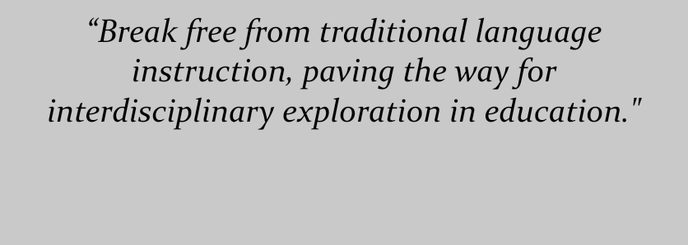

Here I am, standing in front of a classroom filled with eager young minds ready to embark on a journey of language exploration, as the sun rises over the bustling city of Kendari in Southeast Sulawesi. For two decades, I've dedicated my life to teaching English as a Foreign Language (EFL) in Indonesia. Witnessing the transformative power of effective communication has been awe-inspiring. Yet, a spark within me pushes for something more, something that goes beyond the norm of language classes.

As the sun paints the sky in hues of gold, I find myself lost in thought, pondering the limitations of the traditional linear approach to language teaching. It's not just about memorizing grammar rules and vocabulary anymore. My passion for education burns brighter, fueled by a desire for a holistic approach that doesn't just build language skills, but also interconnects knowledge like never before.

In the words of someone wise, "The only thing that is constant is change." This phrase resonates with me as I embark on a daring new path. The decision to pursue a Ph.D. in Asia-Pacific Regional Studies (APRS) at National Dong Hwa University comes with challenges. Doubts arise from my unconventional academic and professional background, especially in the realm of international relations (IR). "The biggest risk is not taking any risk," another voice reminds me.

Despite the uncertainties, I press on, my thirst for knowledge unquenchable. The first month of my APRS journey is a rollercoaster of anxiety and excitement. Enrolling in courses like Southeast Asia Policy and Regional Studies, I'm beginning to witness firsthand the profound role language plays in understanding and engaging with complex policy issues. Phrases and structures from my studies become tools that enhance my communication skills, allowing me to express ideas from diverse disciplinary angles. The truth dawns on me: blending multidisciplinary elements isn't just appealing, it's vital for effective communication.

Each passing day strengthens my conviction in the value of embracing multiple fields. The lessons from Southeast Asia Policy and Regional Studies intricately weave into my future language instruction. It's through this fusion that I see the power of interdisciplinary education. I'm determined to integrate these fresh perspectives into my teaching, driven by the transformative potential of interdisciplinary approaches. As someone once said, "Education is the most powerful weapon which you can use to change the world."

So, in my ideal classroom of the future, traditional language education harmoniously coexists with interdisciplinary content. Students aren't just learning a language; they're actively engaging with a vast interconnected web of knowledge. This shift is my commitment, inspired by the potential to ignite intellectual curiosity and a deeper grasp of the English language.

With hope in my heart and a resolute spirit, I step forward, knowing that my journey into the world of multidisciplinary exploration has only just begun. This path isn't just mine; it's an invitation to fellow EFL instructors to break free from the confines of convention and embrace the beauty of interconnected knowledge. Together, we have the power to revolutionize English language instruction, arming our students with the skills they need to communicate effectively and profoundly. As the saying goes, "The journey of a thousand miles begins with a single step."

**Chapter 2**

**Exploring the Asia-Pacific: Unveiling a New Academic Landscape**

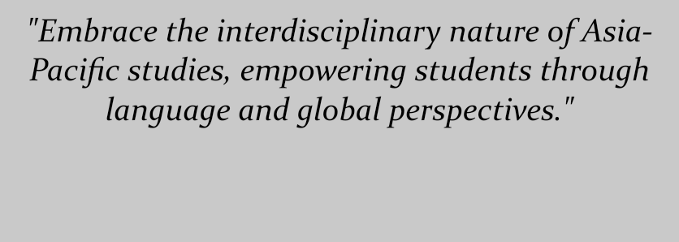

So, here I am, embarking on a wild exploration into the realm of Asia-Pacific Regional Studies (APRS). Buckle up, because as I plunge headfirst into this stuff, I'm discovering a whole new academic universe that's both full of opportunities and riddled with challenges. This chapter is all about my journey through the ups and downs, as I navigate a world that's new to me and, frankly, a bit daunting. As an English as a Foreign Language (EFL) teacher stepping into this arena without any formal international relations (IR) training, I've got goals, worries, and a story to tell.

Let's kick off this adventure with my enrollment in the APRS program at the awesome National Dong Hwa University in Taiwan. As I'm immersing myself in the world of Asia-Pacific studies, it's like realizing I've only been dipping my toes in the ocean of academia. I'm feeling like a bit of a newbie, and to be honest, the lack of an IR background is giving me the jitters. How do I tackle this uncharted territory and bridge the gap between interdisciplinary studies and my EFL teaching expertise?

Fast forward to my first APRS classes, and it's like I've stepped into a whirlwind of mind-bending ideas, theories, and fancy-sounding terms. This stuff hits hard, and I'm grappling with understanding the nitty-gritty of state interactions, regional dynamics, and mind-boggling geopolitical issues. It's overwhelming, and I start wondering if I can ever translate this into something meaningful for my teaching.

But guess what? Amidst all the chaos, a lightbulb flicker on. I'm struck by the sheer impact that understanding the Asia-Pacific region can have on my future students' language development. The key to real communication isn't just grammar and vocabulary; it's about grounding language in the social, political, and economic contexts of the area. It dawns on me that diving into APRS might just be the ticket to equipping my students to engage with the diverse perspectives and challenges of our interconnected world.

So, picture this: I'm diving headlong into the APRS coursework, facing its challenges like a warrior. To tackle the enigma of IR theories and frameworks, I'm not shy about seeking wisdom from my professors and fellow students. With determination and a touch of stubbornness, I'm slowly piecing together the puzzle and actually managing to bridge the gap between theory and practice. Who knew, right?

As the chapter progresses, I'm pondering how all this APRS excitement meshes with my future gig as an EFL teacher. I'm diving deep into the potential of interdisciplinary knowledge to jazz up my teaching game. By the time this chapter wraps up, I've come a long way from my initial struggles to understand this Asia-Pacific gig. I've not only embraced the interdisciplinary nature of APRS but also managed to weave connections between the challenges of regional studies and the art of language instruction. I'm walking away with newfound confidence and the knowledge that this dive into the world of interdisciplinary study is bound to pay off big time for me and my future students.

As the saying goes, "Adventure is worthwhile in itself." This adventure is just getting started, and I'm all in!

**Chapter 3**

**Bridging Language and Policy: The Intersection of Language and Southeast Asia Policy**

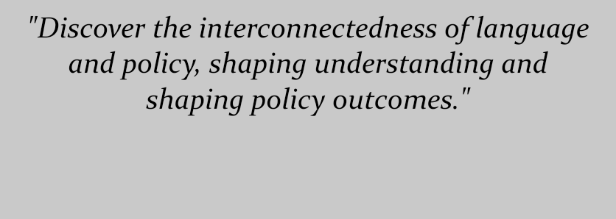

In this chapter, we're diving into a seriously intriguing investigation where language and the Southeast Asia Policy course collide in unexpected ways. Brace yourselves as we journey through the twists and turns of the intricate dance between language and policy. We're talking about how language isn't just words on a page; it's the key to unlocking the complex political puzzle of Southeast Asia.

As one wise mind put it, "Language shapes the limits of our world, constraining and enabling what we can think and discuss." When I hopped onto the Southeast Asia Policy course bandwagon, little did I know that I was embarking on an adventure of linguistic proportions. I mean, seriously, who would've thought language had such a sneaky influence on policy decisions?

But here's the thing – language isn't just a tool; it's like a magical wand for policymakers. It's a way to cast spells of influence and paint pictures of diplomacy. As another insightful person once said, "In the world of policy, language is the brush and ideas are the colors." And boy, does this chapter paint a vivid picture of how linguistic quirks can sway the outcomes of policy decisions. It's like discovering a secret recipe for political persuasion!

Picture me, fully immersed in this course, surrounded by a whirlwind of policy-related concepts and their linguistic counterparts. It's like diving into a sea of diplomatic discussions, regional teamwork, and all the nitty-gritty of Southeast Asian politics. I'm starting to see that language isn't just a communication tool; it's the ultimate bridge (and sometimes a sneaky barrier) to forming agreements, fostering understanding, and tackling regional challenges.

Now, things get juicy when we explore real-life cases that spotlight the immense influence of language on policy talks. It's like watching a master illusionist reveal the tricks behind their magic – except this time, it's about rhetorical devices, shrewd linguistic choices, and the art of steering policy discussions. Step by step, I'm unraveling the intricate threads that weave together the socio-cultural, historical, and political fabric of Southeast Asian policy outcomes. And trust me, this newfound wisdom is totally revamping my future English teaching game.

And here's where the real magic happens. I'm connecting the dots between policy and language, determined to give my future students an unforgettable learning experience. It's like discovering a treasure map that leads to empowered students who can navigate the treacherous waters of global challenges. I mean, who doesn't want to equip the next generation with the tools to tackle the world's issues head-on?

So, off I go, brewing up a concoction of teaching methods that blend policy discussions, case studies, and mind-boggling critical analysis into my language classes. My mission? To mold my students into brilliant minds, skilled debaters, and eloquent communicators. Who knows, they might just be the change-makers our world needs, all thanks to a little sprinkle of policy insight in their language lessons.

But it doesn't end there. I'm going beyond the classroom walls, breaking down barriers between language learning and real-world issues. It's like adding a splash of reality to our language lessons, making them richer, deeper, and oh-so-much more engaging. With this approach, students are discovering that language isn't just a tool for ordering food on vacation; it's a bridge to understanding different cultures and becoming global citizens.

Alright, hold on to your seats, because here's the grand finale. My ultimate goal is to unleash a bunch of language-savvy warriors into the world – individuals who are ready to tackle global problems head-on. It's like arming them with the ultimate power to transform ideas into action, just like superheroes saving the day. With policy topics as their secret weapon, these students won't just talk the talk; they'll walk the walk of change and progress.

And there you have it, folks! This chapter has taken us on a rollercoaster ride through the intertwined worlds of language and policy. Who would've thought that something as simple as language could have such a monumental impact on shaping the future? So, the next time you're teaching or learning a language, remember, you're not just mastering words; you're gaining a superpower that can shape the world.

**Chapter 4**

**Unraveling Language Constructs: Grammar, Phrases, and Sentence Construction**

**in APRS**

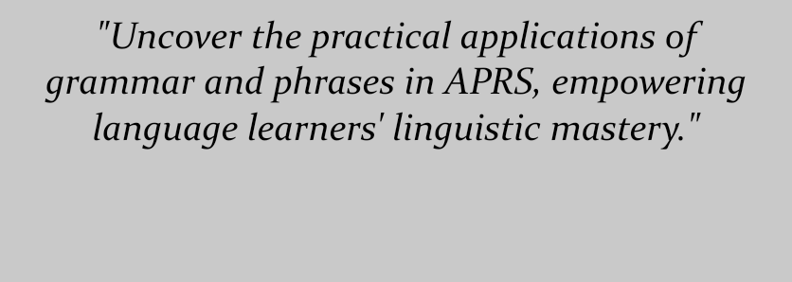

Hey, get ready for a linguistic adventure in the world of Asia-Pacific Regional Studies (APRS) as we dive into the nitty-gritty of grammar, phrases, and all things sentence structure. This chapter is like a treasure map guiding us through my experiences in APRS and how I'm turning those language gems into teaching gold. So, hold onto your seats as we explore the magical world where language meets real-world application.

As one language enthusiast once wisely said, "Grammar is the scaffolding upon which communication is built." So, here's the deal – we're talking about how mastering the syntax, vocabulary, and sentence structure of APRS isn't just a language lesson; it's like wielding a linguistic superpower in both academic and professional realms. It's like being handed the keys to unlock a world of effective communication.

Now, let's talk about my journey through the APRS curriculum. At first glance, the grammatical constructions and expressions seemed like a maze of confusion. But, hold up, that's where the second captivating quote comes in: "In every difficulty lies opportunity." As I dove into these linguistic nuances, I realized that understanding them was the key to unraveling complex concepts within APRS. It's like learning the secret language of a whole new world.

Oh boy, let's not forget the struggles! Learning new grammatical conventions can be like deciphering a cryptic code. From wrestling with intricate verb tenses to tackling those pesky conditional clauses, I've been there, done that. But hey, perseverance pays off, and now I'm standing tall on a solid foundation of linguistic skills, ready to conquer the APRS realm.

Now, brace yourself for the real-world action. We're not just stopping at the classroom door; we're taking these language skills out for a spin in the real world. Think of it as language empowerment in action. Whether it's engaging in academic discussions, networking like a pro, or nailing interviews, precise language usage can transform how you interact and communicate in the APRS context.

Time to switch gears and talk about teaching methods! Ever wondered how language elements can be incorporated into lessons? Well, wonder no more! I've been on a quest to create a language-rich environment that's a perfect blend of grammar exploration, phrase play, and sentence structure showdowns. It's like giving my future students a backstage pass to the world of language, complete with authentic examples and engaging materials.

But wait, there's more – communication activities are the name of the game. Imagine classroom role-plays that feel like stepping onto a real-world stage. It's like learning through experience, where students not only enhance their language skills but also build confidence and fluency. Who said learning can't be a blast?

Now, let's shift to a collaborative approach. Think teamwork, think dynamic group tasks, and stimulating discussions. Collaborative learning isn't just about sharing answers; it's about nurturing critical thinking, problem-solving, and an exchange of diverse viewpoints. As another quote aptly puts it, "Alone we can do so little; together we can do so much."

And speaking of growth, feedback is the secret sauce. Imagine timely advice that helps students navigate the tricky waters of language constructions. It's like having a language mentor guiding you every step of the way. With targeted support and actionable feedback, students become empowered to analyze their language use, pinpoint areas for improvement, and boost their communication skills.

Alright, let's wrap it up. By putting all these cutting-edge techniques into action, I'm leveling up my language teaching game. I'm not just building a solid foundation in grammar and language structure; I'm shaping students into critical thinkers who can wield their linguistic knowledge like a pro. It's like giving them the tools they need to conquer the language landscape, one conversation at a time. So, buckle up – the journey to linguistic success has just begun!

**Chapter 5**

**Classroom Challenges: Navigating Discussions and Linking APRS with Language Teaching**

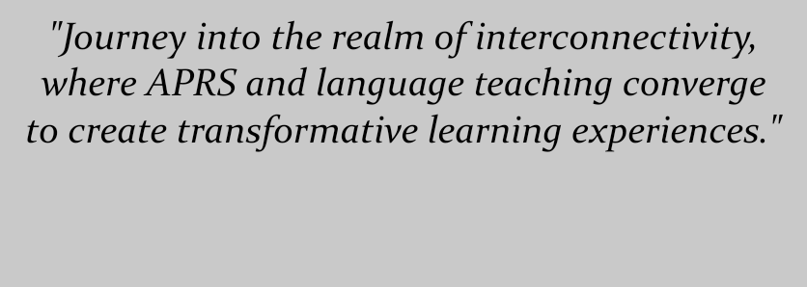

Buckle up because we're diving headfirst into the realm of Asia-Pacific Regional Studies (APRS) and English language education. Get ready for a candid chat about all the classroom stuff in this chapter. We're talking concerns, strategies, and solutions – no filter, just real talk about bridging the gap between these two worlds.

Let's kick things off with a bang, shall we? As they say, "Dialogue is not just about talking; it's about listening." So, here's the scoop – fostering meaningful discussions in the classroom is a game-changer. But let's be real, managing diverse opinions, maintaining structure, and creating a respectful vibe can sometimes feel like herding cats.

Now, imagine me, stepping into the ring as a discussion facilitator. Yep, it's like being the referee of a lively debate match. But, hang on, there's another quote coming in hot: "In every challenge lies a lesson." I'm dishing out my experiences of handling stronger voices, coaxing quieter ones to speak up, and defusing potential debates. And you bet I've got some valuable lessons up my sleeve – like setting clear ground rules, nailing communication techniques, and encouraging active listening.

Now, let's rewind a bit. Remember when APRS knowledge seemed like a foreign language in the world of English teaching? Well, I've been there, done that. It's like trying to mix oil and water, but hey, it's all about finding that sweet spot. And here's the plan: I'm tackling the balancing act between language skills and content comprehension. I'll delve into the challenges of adapting APRS material for various proficiency levels and creating the ultimate learning experience.

Alright, teachers and learners, listen up – it's strategy time! Picture me, the seasoned educator, spilling the beans on how to blend APRS and language instruction seamlessly. Step one? Choose materials that resonate with students' interests and goals. Think authentic texts, captivating case studies, and multimedia magic. It's like cooking up a learning potion that's both flavorful and educational.

But hold on, there's more to explore! Let's talk cutting-edge strategies, like the superhero of education – project-based learning. It's like unleashing student detectives to investigate current events while sharpening their language skills. And here's another trick up my sleeve: experiential learning. Think field trips, guest speakers, and role-playing. It's like learning by doing, and trust me, it's a game-changer.

But hey, no journey is complete without addressing the elephant in the room – integrating APRS with language instruction can be a tad daunting. Enter the solutions! First up, adapting materials. Personal insight time: customizing resources to match students' interests and cultural backgrounds. And guess what? I've got a playbook of practical solutions for you. Think reliable sources, simplified information, and visuals to enhance understanding.

Next up, let's tackle assessments – because who doesn't love those, right? Personal insight: blend traditional assessments with engaging techniques. Now, for the practical scoop: creating tests that measure both language proficiency and APRS knowledge. Imagine realistic scenarios, self-evaluation opportunities, and assessment rubrics. It's like giving assessments a fun twist.

Time for a tech boost – Computer-Assisted Language Learning (CALL) to the rescue! Personal insight: CALL is a game-changer for language acquisition. It's like having a language coach on your device. And here's the practical scoop: interactive features, gamified challenges, and virtual conversational partners. CALL tools are like a Swiss Army knife for language learners, helping them become independent language warriors.

Last but not least, let's build a cozy classroom environment. Personal insight: creating a space where students feel safe to share and learn. The practical solution? Establishing clear communication guidelines, embracing cooperative learning, and encouraging empathy. It's like crafting a classroom vibe where learning and respect go hand in hand.

And there you have it, folks! This chapter is like a treasure trove of insights, strategies, and real talk about integrating APRS and language instruction. So, whether you're a teacher or a student, there's something here for everyone. Keep these tips and tricks in your back pocket, and let's embark on this learning journey together. After all, a little effort goes a long way when it comes to bridging the language and content divide.

**Chapter 6**

**Interdisciplinary Pedagogy: Embracing Content from Various Disciplines**

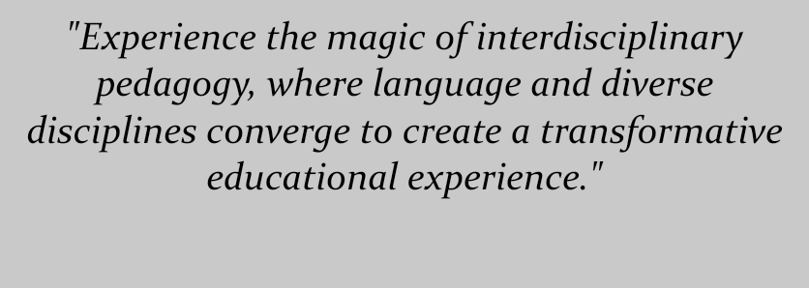

Let's dive into the world of education innovation where we're breaking down classroom walls and mixing things up. Imagine this: a language class that's not just about grammar and vocab, but a gateway to history, science, literature, and art. Yep, I'm talking about interdisciplinary pedagogy, a game-changer that's about to flip the script on language education.

Picture this: "Education is not the filling of a pail, but the lighting of a fire." Now, let's dive in. Interdisciplinary pedagogy is like a treasure hunt for knowledge, where language becomes the key to unlock a world of exploration. Forget boring textbooks; we're stepping into a world where language and learning are intertwined like never before.

One way to rock this interdisciplinary boat? Content-based instruction. Imagine learning vocab and grammar through gripping historical events or cool science experiments. It's like learning language while uncovering hidden gems from different fields. As another wise soul once said, "Learning is an experience. Everything else is just information." So why not make language education an exciting experience that sparks curiosity and fuels communication skills?

But hold on, the journey gets even cooler with project-based learning. Imagine students teaming up to create multimedia presentations on artists or scientific breakthroughs. It's like learning while building real-world skills – researching, analyzing, and presenting confidently. And guess what? "Learning is doing, and only doing, something can be learned." That's the second captivating quote that fits perfectly here. When students see language in action, it's like the missing puzzle piece clicks into place.

Now, let's talk tech, because the future is digital. Think virtual reality, engaging online tools, and multimedia magic. With technology as our sidekick, we're not just learning about different fields; we're experiencing them firsthand. It's like going on a global adventure without leaving the classroom. And guess what? Tech isn't just a tool; it's a bridge that connects language and other subject areas.

But here's the real magic trick – collaboration. Imagine teachers from different fields coming together to create a super-powered curriculum that seamlessly weaves language education into other subjects. It's like superheroes teaming up to save the education universe. Together, we're not just enriching students' learning; we're also nurturing our own professional growth.

Now, here's the secret sauce: flexibility and innovation. "The art of teaching is the art of assisting discovery." That's another gem that fits here. The educational landscape is ever-changing, so staying open-minded and adaptable is the key to unleashing the full potential of interdisciplinary pedagogy. As we keep our eyes on the horizon, we're pushing boundaries, rewriting the rules, and creating a new era of education.

Let's wrap it up with a big picture view. Interdisciplinary pedagogy isn't just about subjects coexisting; it's about creating a holistic education. It's like building a custom toolbox for students – one that's filled with language skills, critical thinking, and a lifelong love of learning. So, buckle up, because we're embarking on a journey where language isn't just a subject; it's a passport to endless opportunities in our connected and dynamic world. Together, we're changing the game, one interdisciplinary adventure at a time.

**Chapter 7**

**Breaking Linear Thinking: Emphasizing the Interconnectedness of Knowledge**

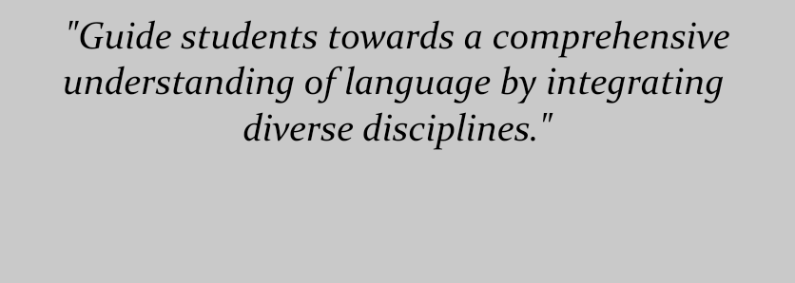

Get ready for a mind-bending journey as we challenge the status quo in this chapter. We're diving headfirst into a world that shatters the notion of linear thinking and embraces the idea that knowledge is one big, beautiful web. So, let's break free from the old ways and reimagine education as an interconnected adventure.

First things first, let's drop some wisdom: "The web of our life is of a mingled yarn, good and ill together." Alright, let's get down to business. Traditional learning often keeps subjects in their separate little boxes, and that's a major buzzkill for understanding the bigger picture. It's like learning the ingredients of a cake but never getting to taste the final product. So, hold on tight, 'cause we're about to flip the script.

Time to put on our critical thinking hats and dive deep into the rabbit hole of linear thinking. Picture this: subjects being taught in isolation, like lonely islands in a vast ocean of knowledge. Now, imagine the lightbulb moment when you realize, "Hey, all these islands are connected by bridges!" That's the second captivating quote that fits like a glove. Fragmented learning doesn't do justice to the complex interplay of ideas and concepts. It's time to tear down those walls and embrace a web of knowledge.

But here's where it gets really exciting. Imagine learning that's not just about memorizing facts, but about understanding how those facts relate to each other. It's like discovering that every puzzle piece has a place and a purpose. As I journey through this revolutionary path, I'm constantly cooking up ways to create learning environments that encourage students to connect the dots between different subjects. It's like weaving a tapestry of knowledge that's rich, diverse, and oh-so-cool.

Now, let's dive into the specifics. Imagine a world where science and language aren't distant cousins but best buddies. It's like peanut butter and jelly – they just go together. In this future scenario, students don't just read about science; they dive into experiments, discuss ideas, and even publish scientific papers. It's like learning language while unraveling the mysteries of the universe.

But hold on tight, 'cause we're not stopping there. Imagine students tackling big issues like climate change from every angle – science, geography, economics, and language. It's like a supercharged approach to problem-solving. By breaking down subject barriers, we're not just nurturing language skills; we're nurturing critical thinking, problem-solving, and a deeper understanding of the world around us.

But the real secret sauce? A growth mindset. Imagine students seeing themselves as explorers, constantly seeking connections between different fields. It's like being a knowledge detective, always on the lookout for hidden truths. And here's the deal: "Change is the end result of all true learning." That's the third captivating quote that fits like a glove. By nurturing curiosity, adaptability, and open-mindedness, we're equipping students for a lifetime of learning adventures.

As we delve deeper into this chapter, we're not just talking theories – we're dishing out practical advice. Imagine cross-curricular modules that blend subjects seamlessly. It's like creating a learning experience that's as vibrant and interconnected as the real world. And don't forget collaborative projects; they're like a teamwork-fueled rocket that blasts learning to new heights.

But let's be real – this isn't your grandma's teaching method. It's a revolutionary leap into a world where knowledge isn't a bunch of isolated islands; it's a vast ocean with interconnected currents. By challenging linear thinking and embracing an integrated approach, we're opening doors to endless learning possibilities. So, fellow educators, let's journey together and create a future where interconnectedness rules the classroom. It's a new era of learning, and we're at the forefront. Let's make it count!

**Chapter 8**

**Language as a Medium: Communicating Ideas in an Interdisciplinary Context**

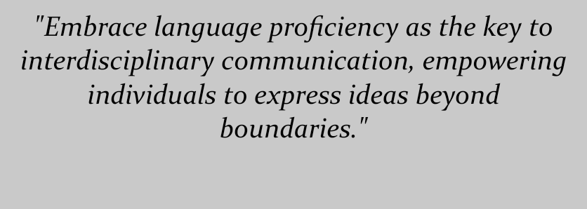

Let's dive into a chapter that's all about the power of words, connections, and breaking down the walls between disciplines. Get ready to explore how language isn't just a way to chat; it's a force that bridges gaps and unlocks a world of interdisciplinary wonders.

First up, let's drop some wisdom: "Language is the road map of a culture. It tells you where its people come from and where they are going." Alright, let's kick things off. Language isn't just a bunch of words; it's the vehicle that takes ideas on a journey. In this chapter, we're diving deep into the rabbit hole of how language proficiency is like the secret sauce for effective communication in an interdisciplinary playground.

Now, picture this: you're at a grand party, and everyone speaks a different language. How do you connect? Well, that's what interdisciplinary communication is like – a party where different subjects need to mingle. But guess what? Language is the ultimate icebreaker. It's like the DJ that gets everyone on the dance floor, grooving to the same beat. We're not just talking about language; we're talking about creating bridges between different fields of knowledge.

But wait, there's more to this than meets the eye. Imagine a classroom where everyone's opinions matter, and there's no one-size-fits-all answer. It's like a brainstorming session where every idea is a gem waiting to be discovered. That's the second captivating quote that fits the puzzle perfectly. With the help of interdisciplinary communication, we're encouraging students to express themselves freely, embrace diverse perspectives, and challenge the status quo.

Now, let's roll up our sleeves and get practical. Imagine students not just learning syntax and vocabulary but also mastering the art of dissecting complex texts and wielding discipline-specific jargon like a pro. It's like giving them a Swiss Army knife for knowledge exploration. By fostering interdisciplinary language skills, we're creating a generation of communicators who can navigate the intricate web of various fields.

But here's the exciting twist – bringing real-world issues to the language classroom. Imagine discussing climate change, cultural diversity, or scientific breakthroughs as part of your language lessons. It's like combining learning with your favorite Netflix binge. By intertwining language with interdisciplinary topics, we're sparking curiosity, nurturing critical thinking, and giving students a taste of the real world.

And let's not forget the magic of conversation. Imagine a classroom where students don't just listen but actively engage in meaningful discussions across disciplines. It's like a roundtable of thinkers, sharing ideas and pushing boundaries. Through active listening, thought-provoking questions, and respectful debates, students are learning to communicate effectively while embracing diverse viewpoints.

Now, get ready for some real-life inspiration. Imagine scientists collaborating with linguists, artists teaming up with historians, and language becoming the bridge that connects them all. It's like a symphony of ideas that leads to breakthroughs and innovation. Through stories and anecdotes, we're showing how interdisciplinary language use isn't just powerful; it's transformative.

And here's the call to action: Let's embrace language as more than just a way to chat. It's a force that unites knowledge, bridges gaps, and paves the way for groundbreaking interdisciplinary research. So, educators of all stripes, take a leap into this transformative strategy. Let's give our students the tools they need to thrive as communicators, critical thinkers, and lifelong learners. It's a journey that goes beyond words – it's the gateway to a future where interdisciplinary connections reign supreme. So, are you ready to join the movement? Let's break down those academic barriers and watch language weave its magic!

**Chapter 9**

**Integrating Interdisciplinary Content: Enriching Language Teaching Practices**

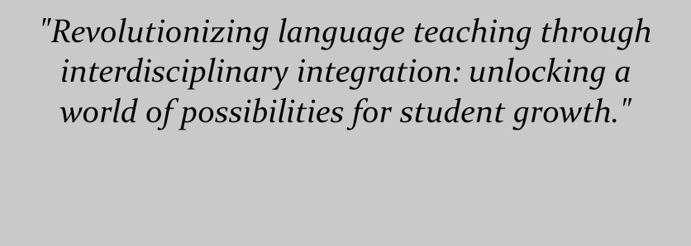

Buckle up, because we're diving into a chapter that's all about shaking up language teaching. I'm buzzing with excitement as I share my grand plans to revolutionize my teaching game and sprinkle a dash of interdisciplinary magic. Get ready for a sneak peek into how I'm gearing up to create a learning experience that's not just about language but about opening up whole new worlds of knowledge!

Let's kick things off with a dose of wisdom: "The future belongs to those who believe in the beauty of their dreams." Alright, here's the deal – traditional language teaching can be like wearing blinders; we're so focused on grammar and vocab that we miss the rich tapestry of information around us. But guess what? It's time to dream big and believe that language teaching can be so much more than what we've known.

Slowly but surely, I've come to realize the limitations of the old ways. It's like trying to build a skyscraper with just a hammer; you need a whole toolbox to make it work. And that's where interdisciplinary teaching swoops in like a superhero. It's like adding a bunch of tools to your teaching toolkit, giving students more than just language skills – it's about expanding their minds and opening doors they didn't even know existed.

So, here's the game plan: imagine a classroom where language isn't just a subject but a portal to the world of history, culture, science, and more. It's like making learning a full-on adventure, where students explore various subjects through the lens of language. By weaving these topics into language sessions, we're giving students a holistic education that nurtures their curiosity and fuels their love for learning.

But here's where things get really exciting. Imagine students diving into interdisciplinary projects that challenge their language skills while exploring different academic areas. It's like solving a mystery while learning a new language – double the excitement! By assigning tasks like presenting historical events in English, we're not just teaching language; we're nurturing critical thinkers who can connect the dots across diverse fields.

And here comes the treasure hunt: imagine digging into authentic materials from various disciplines. It's like using real artifacts to learn about history – except we're diving into different subjects. By exposing students to writings, publications, and cultural artifacts, we're not just teaching them words; we're showing them how language is intertwined with the world around them.

But we're not stopping there – let's talk teamwork. Imagine students collaborating, discussing, and debating across disciplines. It's like a brainstorming session where every student brings a different piece of the puzzle. Through group activities, discussions, and projects, we're nurturing not just language skills but also teamwork and the art of seeing things from different angles.

And here's my commitment: I'm not just talking the talk; I'm walking the walk. Imagine a teacher who's constantly learning, evolving, and broadening their horizons. It's like becoming a student all over again, always hungry for new knowledge. By staying updated through seminars, conferences, and collaboration with specialists, I'm making sure my teaching is as fresh and interdisciplinary as it gets.

Now, don't get me wrong – this journey won't be all rainbows and unicorns. There will be challenges, like finding the right resources, aligning with standards, and adapting to new strategies. But guess what? It's all part of the adventure. I'm ready to embrace the bumps, the twists, and the unexpected turns. Because at the end of the day, it's all about giving my students a richer, more fulfilling language-learning experience.

So, fellow educators, join me on this ride as we pave the way for a future of interdisciplinary language teaching. It's not just about teaching words; it's about unleashing the power of knowledge, curiosity, and connection. Let's dive in, break the mold, and watch as our students' worlds expand beyond their wildest dreams!

**Chapter 10**

**Inspiring a New Generation: Encouraging EFL Teachers on the Interdisciplinary Path**

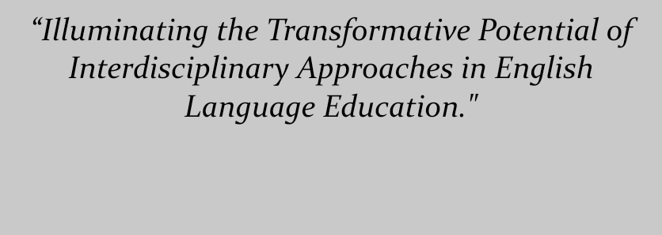

We've arrived at the final stop on this transforming ride, and man, what a ride it's been. Time to kick back, reflect, and sprinkle some inspiration as we delve into the game-changing world of interdisciplinary language teaching. So, grab a seat, because this chapter is all about looking back, taking charge, and paving the way for a future that's nothing short of amazing.

Hold onto your hats, because I've got a gem of a quote to kick things off: "The only limit to our realization of tomorrow will be our doubts of today." And let me tell you, doubts be gone! I'm standing here, gazing back at this journey, feeling like I've just unlocked a superpower. A sense of purpose is coursing through me, and I'm on a mission to light the way for fellow EFL teachers who are ready to take the multidisciplinary plunge.

Okay, let's get real for a moment. Asia-Pacific Regional Studies, you've been a game-changer. It's like I've discovered a whole new universe where language isn't just words; it's bridges connecting cultures and ideas. Dive into this field, and you'll see how language doesn't just help us communicate – it has the power to create deep bonds and mend cross-cultural fences. It's like a secret weapon for global understanding!

Now, brace yourself for a reality check: our world is complex. But guess what? Multidisciplinary thinking is our superhero cape. I've seen it in action during my adventures in Asia-Pacific Regional Studies. The ability to navigate politics, economics, and social dynamics with language fluency? It's like a ticket to the international debate club. And here's the magic trick: we can sprinkle this brilliance into our language classes, making our students global citizens who see the world in a whole new light.

It's like crafting a masterpiece – blending language with international relations. With this combo, we're not just teaching English; we're fostering a generation of thinkers who can grapple with global challenges and dance through cultural diversity. It's like teaching them the language of the world, and I'm all in.

And guess what, fellow educators? We've got front-row seats to shaping the future. It's like being entrusted with a sacred treasure: our students' minds. By weaving Asia-Pacific Regional Studies and interdisciplinary thinking into our language education, we're helping our students become the rock stars of intercultural communication. They'll tackle tough conversations, understand diverse perspectives, and dive into global issues headfirst.

So, here's my rallying cry: fellow EFL instructors, it's time to roll up those sleeves and dive into the multidisciplinary waters. Let's blend language and international relations, creating an education that's as rich as a gourmet feast. Our students aren't just learning words; they're understanding the heartbeat of our interconnected world.

And as we wrap up this journey, remember this: we're not just teachers; we're torchbearers. So, fellow educators, let's light up the path for our students. Let's unleash the potential of interdisciplinary approaches in English language teaching, so our students not only speak the language but also understand its role in international relations. With every word we teach, every connection we make, we're shaping a world where language bridges cultures, sparks understanding, and sparks global change.

**Summary of the Novel**

**Chapter 1: Crossing Boundaries: My Brave Leap into Interdisciplinary Terrain.** In this chapter, I describe my experience teaching English as a foreign language (EFL) and my desire to pursue interdisciplinary language teaching. I draw attention to the necessity of enlarging my perspectives and embracing many fields of knowledge in order to effectively communicate.

**Chapter 2: Exploring the Asia-Pacific: Unveiling a New Academic Landscape.** This chapter explores my studies in Asia-Pacific Regional Studies (APRS) and consider the first difficulties I encountered as a result of my lack of experience in international relations. I go over my reasons for taking the course, my worries about it, and how it relates to my future as an English teacher.

**Chapter 3: Bridging Language and Policy: The Intersection of Language and Southeast Asia Policy.** This chapter covers the connections between language study and the Southeast Asia Policy course that I found. I talk on the crucial role language plays in comprehending and engaging with policy-related issues and how these realizations might be used to my future teaching methods.

**Chapter 4: Unraveling Language Constructs: Grammar, Phrases, and Sentence Construction in APRS.** In this chapter, throughout my APRS courses, I had the opportunity to master a variety of grammatical structures, phrases, and sentence forms. I describe methods for incorporating these language components into language training while highlighting how I use them in my everyday conversation.

**Chapter 5: Classroom Challenges: Navigating Discussions and Linking APRS with Language Teaching.** My initial concerns about classroom discussions and the incorporation of APRS knowledge into English language instruction are addressed in this chapter. I consider the methods I used to get around obstacles and create useful links between each field.

**Chapter 6: Interdisciplinary Pedagogy: Embracing Content from Various Disciplines.** This chapter examines the idea of interdisciplinary pedagogy and its relevance to teaching languages. I go into detail on the value of integrating material from other academic fields to improve students' understanding of the English language and encourage a well-rounded attitude to education.

**Chapter 7: Breaking Linear Thinking: Emphasizing the Interconnectedness of Knowledge**. This chapter emphasizes arguing against linear thinking and advancing the idea that information is interrelated. I outline my goal of assisting students in understanding the connection between many academic fields and how it improves language proficiency.

**Chapter 8: Language as a Medium: Communicating Ideas in an Interdisciplinary Context.** In this chapter, in an interdisciplinary setting, I investigate the function of language as a means of efficient communication. I go over how being able to articulate ideas from diverse disciplines and participate in fruitful conversations is made possible by language skills.

**Chapter 9: Integrating Interdisciplinary Content: Enriching Language Teaching Practices.** The purpose of this chapter is to discuss how I want to include interdisciplinary topics into my future teaching strategies. To encourage students' intellectual development and language development, I go over methods for introducing a variety of topic matter into language courses.

**Chapter 10: Inspiring a New Generation: Encouraging EFL Teachers on the Interdisciplinary Path.** In the final chapter, I consider my experience and express my desire to motivate other EFL instructors to adopt multidisciplinary strategies. In order to improve English language education, I emphasize the transformative potential of interdisciplinary language instruction.

**Author Biography**

Abdul Halim, an educator from Indonesia, has spent about 17 years of his career teaching at IAIN Kendari. He has nourished the minds of several students and stoked their love of learning with his unshakable dedication to education. His pursuit of academic success led him to the esteemed University of Canberra in Australia to complete his Master's degree program in TESOL. He expanded his knowledge and improved his teaching techniques by delving deeply into the fields of applied linguistics, language learning, and cross-cultural understanding.

Abdul Halim creates a vibrant and engaging learning environment by seamlessly integrating his research passions into his teaching. Through his creative teaching strategies, his enthusiasm for applied linguistics, language learning, and intercultural understanding is evident. In order to create a learning environment where students may have a deeper understanding of language and cultural distinctions, he understands the value of accepting various perspectives and cultures in the classroom.

Abdul Halim is presently pursuing his Ph.D. at the Department of Asia-Pacific Regional Study at National Dong Hwa University, driven by his insatiable hunger for knowledge. He wants to broaden his horizons and absorb a wider range of academic disciplines through this multidisciplinary curriculum. He hopes to significantly advance the study of language instruction through his research by bridging the gap between linguistic theories and cultural contexts. He wants to equip future generations of educators with a multidimensional grasp of language, people, and culture, which is reflected in his pursuit of a Ph.D.